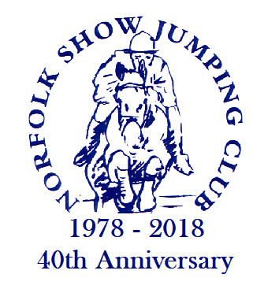 | Saturday 13th Oct 2018  Junior British Showjumping  Easton College, NR9 5GA  Starting at 8:30am | 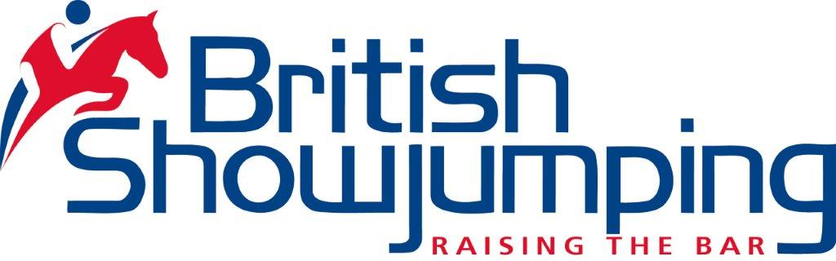
All enquiries to Sue Peasley 07836276290, www.norfolkshowjumping.co.uk
First Aid is provided by an external provider, competitors will be charged £3 towards the costs.
In the event of insufficient entries lower prizes may be withheld. Rule - 76.6
All competitors should be members of Norfolk Show Jumping Club, single: £8, Family: £12, Day: £2
Rosettes generously sponsored by EH Haylage

Class 0 - 08:30 - Clear Round
Open To All, British Showjumping Tack Rules, Conduct Rules & Welfare Policy apply.
Entry Fee = £5.00
Class 1 - 09:00 - Pony Intro 70cm Open
Single Phase. Speed 325mpm. Start Height 70cm.
For registered ponies in Grades: JA, JC & JD to be ridden by junior members.
Prizes: 1st: £20.00, 2nd: £18.00, 3rd: £15.00, 4th: £12.00, 5th: £12.00, Total: £77.00. Entry Fee = £12.00
Class 2 - Pony British Novice Championship - First Round /80cm Open
Rule 410. Table A7. Speed 325mpm. Start Height 80cm. Ponies may compete in one section only.
British Novice: For registered ponies in Grade JD and JC that have not won a total of 150 Points to be ridden by Junior Members, ages as per Rule 77.12/77.13. Qualifies for: Pony British Novice Championship Second Rounds. Qualifying period 1st May-30th April inclusive. Numbers to qualify: Those ponies that jump a clear round in the first round, followed by a clear round in the jump-off, in at least four Pony British Novice First Round competitions held in the qualifying period will qualify to compete in a Pony British Novice Second Rounds, irrespective of their placings for prize money in those competitions, which will be determined by the normal Table A Rules (Rule 191). Ponies in the class must go in to the jump-off and go clear to gain their double clear round qualification. The winner of a particular Pony British Novice First Round competition will not automatically qualify solely as a result of that competition. 80cm Open: For registered ponies to be ridden by Junior Members. In the event of 15 or more starters this class will be split with two sets of prize money.
Prizes: 1st: £25.00, 2nd: £20.00, 3rd: £15.00, 4th: £13.00, 5th: £13.00, Total: £86.00. Entry Fee = £13.00
Class 3 - Pony Discovery -First Round/90cm Open
Rule 408. Single Phase. Speed 325mpm. Start Height 90cm.
Ponies may compete in one section only. Discovery: For registered ponies in Grades JD and JC that have not won a total of 300 Points to be ridden by Junior Members, ages as per Rule 77.12/77.13. Qualifies for: Pony Discovery Second Round. Qualifying period: 1st May-30th April inclusive. Numbers to qualify for: Those ponies which jump a clear round in the first round, followed by a clear round in the jump-off in at least four Pony Discovery First Round competitions held in any qualifying period will qualify to compete in a Pony Discovery Second Round, irrespective of their placings for prize money in those competitions, which will be determined by the normal Table A Rules (Rule 191). Ponies in the class must go in to the jump-off and go clear to gain their double clear round qualification. The winner of a particular Pony Discovery First Round competition will not automatically qualify solely as a result of that competition. 90cm Open: For registered ponies, to be ridden by Junior Members. In the event of 30 or more starters the class will be split with two sets of prize money.
Prizes: 1st: £25.00, 2nd: £20.00, 3rd: £15.00, 4th: £13.00, 5th: £13.00, Total: £86.00. Entry Fee = £13.00
Class 4 - Springboard 128/138cm Handicap
Rule 415. Table A6. Speed 325mpm. Start Heights 90cm / 1.00m. Table A. Two Rounds not against the clock. All equal first in Round One will go forward to Round Two over a shortened course. For registered ponies not exceeding 138cms, to be ridden by Junior Members, ages in accordance with Rule 77.12 & 77.13. This competition is open to all but for qualification purposes: In the 128cms Section Junior riders are eligible to enter, irrespective of Points achieved, before the calendar year in which the age of 10 years is reached. Riders who reach the age of 10 years and over in the current calendar year must not have won a total of 500 Points. (as of 01.08.2017 pony/rider combination). In the 138cms Section, Pony riders are eligible to enter, irrespective of Points achieved, before the calendar year in which the age of 12 is reached. Riders who reach the age 12 years and over in the current calendar year must not have won a total of 850 Points. (as of 01.08.2017 pony/rider combination). Junior Riders are not eligible to enter the 138cms section until the calendar year in which their 8th birthday is reached. 128cms Ponies are not permitted to enter the 138cms section.
Once riders have competed at, or have ‘ever’ qualified for RIHS or HOYS on any height pony they are no longer eligible to compete in the Final. Pony/rider combinations who have accrued points on the Pony Gold League are not eligible to compete in the final of this competition. Qualifies for: Springboard Final. Qualifying Period: 1st August-31st January. Numbers to Qualify: Two double clears to qualify for the Final. Qualification is pony/rider combination. Ponies in the class must go into the jump-off and go clear to gain its double clear round qualification. In order to compete in the Final, all qualified competitors ages must be in accordance with the Rule 77.12 & 77.13 in the year of the Final. No rider may compete more than three ponies in the same section.
Prizes: 1st: £25.00, 2nd: £20.00, 3rd: £15.00, 4th: £13.00, 5th: £13.00, Total: £86.00. Entry Fee = £13.00
Class 5 - Blue Chip Pony Newcomers/Pony 1.00m Open (both to inc. The Pony Restricted Rider 1.00m Qualifier)
Rule 406 & 416. Single Phase. Speed 325mpm. Start Height 1.00m. First place rosette kindly sponsored by Blue Chip In the event of 30 or more starters the class will be split and two sets of prize money awarded.
Blue Chip Pony Newcomers is for registered Ponies in Grade JC & JD that have not won a total of 500 points to be ridden by Junior Members. Qualifies for: Blue Chip Pony Newcomers Second Round. Qualifying period: 1st May-30th April inclusive. Numbers to qualify: Those ponies that jump a clear round in the First Round, followed by a clear round in the jump-off in at least four Blue Chip Pony Newcomers First Round competitions held in any qualifying period will qualify to compete in a Pony Newcomers Second Round. The Open Section is open to all. Registered ponies competing in either the Open or the Newcomers Section, ridden by Junior Members who have not won a total of 500 Points are eligible for double clear qualification for the Pony Restricted Rider 1.00m Championship. Riders who have accrued points on the Pony Gold League are not eligible to compete in the Restricted Rider 1.00m Final. Qualifies for: Four double clears will qualify for the Pony Restricted Rider 1.00m Championship to be held at the British Showjumping National Championships. Qualifying period: 1st May-30th April. Qualification is Pony/rider Combination. Ponies may compete in one section only.
Prizes: 1st: £25.00, 2nd: £20.00, 3rd: £15.00, 4th: £13.00, 5th: £13.00, Total: £86.00. Entry Fee = £13.00
Class 6 - Pony Foxhunter/1.10m Open (both to Inc. The Pony Restricted Rider 1.10m Qualifier) Rule 404 & 417. Table A7. Speed 325mpm. Start Height 1.10m. In the event of 30 or more starters the class will be split and two sets of prize money awarded. Ponies may compete in one section only.
Pony Foxhunter First Round is for ponies in Grades JD and JC that have not won a total of 700 Points to be ridden by Junior Members. Qualifies for: Pony Foxhunter Second Round. Qualifying period: 1st May-30th April inclusive. Numbers to qualify: Those ponies that jump a clear round in the first round, followed by a clear round in the jump-off in at least four First Round competitions held in the qualifying period will qualify to compete in the Second Round. The Open Section is open to all. Registered ponies competing in either the Open or the Foxhunter Section, ridden by Junior members who have not won more than a total of 350 Points in the previous calendar year are eligible for double clear qualification for the Pony Restricted Rider 1.10m hampionship. Riders who have accrued points on the Pony Gold League are not eligible to compete in the Restricted Rider 1.10m Final. Qualifies for: Four double clears will qualify for the Pony Restricted Rider 1.10m Championship to be held at the British Showjumping National Championships. Qualification is pony/rider combination.
Prizes: 1st: £25.00, 2nd: £20.00, 3rd: £15.00, 4th: £13.00, 5th: £13.00, Total: £86.00. Entry Fee = £13.00
Class 7 - British Showjumping Pony National 1.15m Members Cup - First Round
Rule 400. Single Phase. Speed 325mpm. Start Height 1.15m. For registered ponies to be ridden by Junior Members. This competition is open to all, but for qualification purposes, those pony/rider combinations that have been placed in a Winter JA Classic or Pony Show Jumper of the Year will not be eligible to compete in the final. Qualifies for: The British Showjumping National Championships Qualifying period 1st July-30th June.
Numbers to qualify: Two double clears to qualify (subject to revision). Qualification is pony/rider combination.
Prizes: 1st: £25.00, 2nd: £20.00, 3rd: £15.00, 4th: £13.00, 5th: £13.00, Total: £86.00. Entry Fee = £13.00

